  - VLAN and Inter-VLAN Routing with FortiGate
  - HQ‑Branch Network with FortiGate

VLAN and Inter-VLAN Routing with FortiGate

Executive Summary
This project documents the design and implementation of a simulated enterprise network, comprising a Headquarters (HQ) site and a Branch site, using GNS3 virtualization. Each site is equipped with Fortinet FortiGate Next-Generation Firewalls (NGFWs) and Cisco routers/switches to provide realistic enterprise-class security and connectivity. The network was segmented into multiple VLANs, interconnected by router-on-a-stick and switch trunking, and deployed with an IPsec site-to-site VPN between sites. Routing and switching were configured according to the enterprise's best practices. The project demonstrates that a complete, functional corporate network can be built and tested virtually.
In summary, this work achieved the goals of implementing a multi-site enterprise network with secure inter-site connectivity, robust routing (OSPF) and security (NGFW, ACLs, web filtering, etc.), and validation of key CCNA-level concepts (OSI model, IP addressing, VLANs, STP, DHCP, NAT, ACLs).


Figure 1: Project submitted to Digital Egypt Pioneers Initiative

Project Goals and Scope
The goal was to build a realistic multi-site enterprise network in GNS3 that meets CCNA-level requirements and employs advanced security features. Specifically, we aimed to design two connected LAN environments (HQ and Branch) with distinct roles, implement inter-VLAN routing and secure segmentation, and enable site-to-site IPsec VPN connectivity over the simulated “internet.” The scope included configuring FortiGate firewalls (for NGFW protection, VPNs, and security services) and Cisco routing/switching devices (for layer-3 and layer-2 connectivity). As modern enterprise networks converge networking and security, our design integrates firewalls, VLAN segmentation, and secure tunnels across sites.
The project covered the following objectives: establishing VLANs and subnets, assigning IP addressing, configuring OSPF routing and static routes, creating an IPsec VPN (with IKEv2 Phase-1/2 parameters), and enabling network security controls (firewall policies, port security, ACLs, DHCP snooping). All tasks were validated through extensive testing (ping, traceroute, route checks, VPN status) to ensure a robust, enterprise-grade implementation.

Tools and Technologies Used
The network was built and tested in GNS3 (a free network emulator) on virtual machines, allowing the integration of real vendor images without physical hardware. The firewall platform is FortiGate NGFW (FortiOS), chosen for its consolidated security features (firewall, VPN ) and widespread enterprise use.
Cisco IOS devices were used for routing and switching typically Cisco routers and Cisco Catalyst switches (L3-capable) to provide realistic layer-2/3 behavior. Virtual hosts (simulated PCs) ran lightweight OSes or were represented by GNS3 IOUs. Key software and protocols included FortiOS (for firewall/VPN/security), Cisco IOS for routers/switches, SNMP for monitoring, and standard networking protocols (DHCP, DNS, NTP, STP, 802.1Q, ACLs).
All components reflect an enterprise network: routers, switches, and firewalls as core devices, with SNMP monitoring for device health. In summary, the project leverages GNS3 as a virtual testbed, FortiGate NGFWs for consolidated security, and Cisco routers/switches for routing/switching, closely mimicking a production environment.

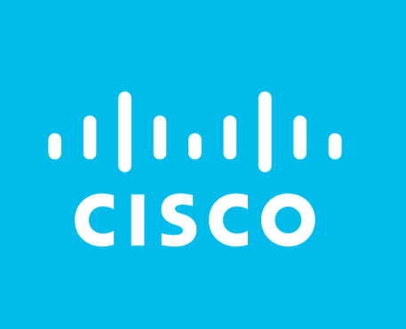
Network Topology Description
The network consists of two sites: the Headquarters (HQ) and the Branch. At each site, a FortiGate firewall connects the LAN to the simulated WAN (Internet) and acts as the security gateway. Behind each firewall, a Cisco router interfaces to the internal switch, which in turn connects to servers and clients. The devices are interconnected as shown in the project diagrams (Appendix Figure 1). For example, at HQ the FortiGate’s LAN interface (e.g., FG-HQ.port1) connects to the HQ Cisco switch’s trunk port; inter-VLAN routing is done via a router-on-a-stick on the Cisco router or by the firewall. The Branch is similar but smaller. An IPsec site-to-site tunnel runs between the FortiGate units over the simulated internet link.
Each site is a distinct network domain connected by WAN: this reflects a typical enterprise architecture where branches extend the campus networks. The HQ site provides central services and inter-site routing, while the Branch relies on HQ for many resources and for Internet access via the VPN. Trunk links (IEEE 802.1Q) carry multiple VLANs between devices (e.g., router ↔ switch, switch ↔ FortiGate). All Ethernet links operate at gigabit speed in simulation, and port configurations include VLAN tagging, native VLANs, and Spanning Tree Protocol (STP) to prevent loops. In summary, the topology is a fully routed LAN at each site, tied together by a secure VPN tunnel, and designed according to enterprise best practices for multi-VLAN and multi-site connectivity.
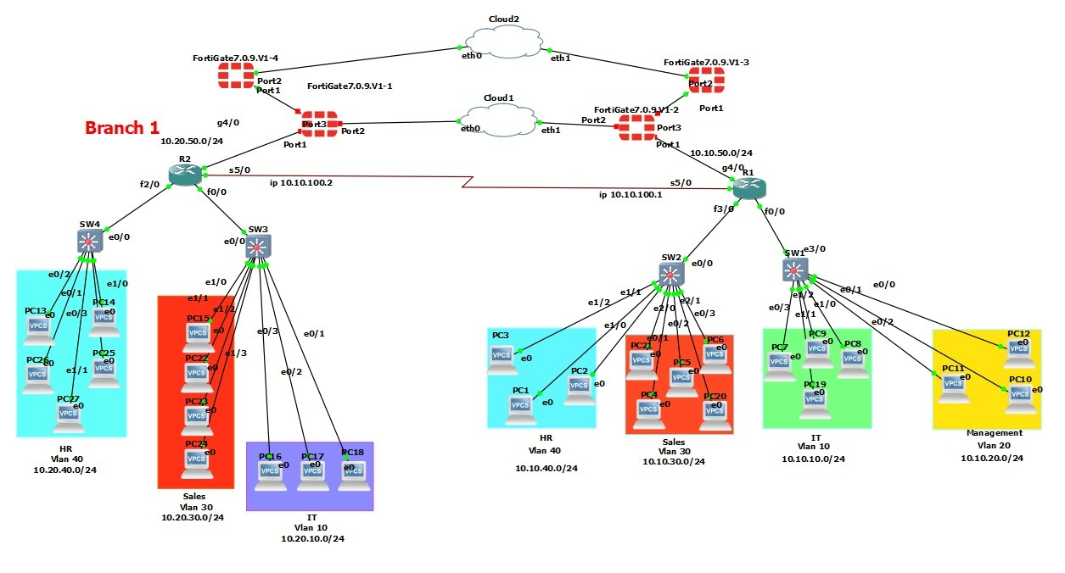
Figure 2: Topology Diagram
IP Addressing Scheme
All internal networks use private IPv4 address space (10.0.0.0/8, 172.16.0.0/12, 192.168.0.0/16) For example, the HQ site uses the 10.0.0.0/16 block; the Branch uses 10.1.0.0/16. Individual VLANs are carved into /24 subnets.
The Branch FortiGate’s WAN interface use a dynamic public address (using DDNS) to connect to the HQ FortiGate. Static route(s) on the branch point include all remote subnets and default traffic toward the VPN. Overall, the scheme follows hierarchical planning: a /16 per site, subdivided into /24 VLANs. We strictly avoid public IPs inside the LAN.
VLAN Overview
Each site’s network is segmented into VLANs by function. Key VLANs (ID, Name, Subnet, SVI IP, Parent Interface) are as follows:
HQ VLANs
- VLAN 10 – IT (10.10.10.0/24)
- VLAN 20 – Management (10.10.20.0/24)
- VLAN 30 – Sales (10.10.30.0/24)
- VLAN 40 – HR (10.10.40.0/24)
Branch VLANs
- VLAN 10 – IT (10.20.10.0/24)
- VLAN 30 – Sales (10.20.30.0/24)
- VLAN 40 – HR (10.20.40.0/24)

All switch-to-router/firewall links are configured as 802.1Q trunks carrying these VLANs, with a consistent native VLAN set. The FortiGate devices handle inter-VLAN routing via virtual LAN interfaces (SVIs) or directly on the firewall, depending on the design. In each VLAN, DHCP servers (on FortiGate or routers) provide IP addresses to hosts, using the subnet’s gateway as the default gateway.

Subnet Summary
Grouped by site, the deployed subnets are:
- HQ Subnets:
- 10.10.10.0/24 – IT
- 10.10.20.0/24 – Management
- 10.10.30.0/24 – Sales
- 10.10.40.0/24 – HR
- 10.10.50.0/24 – Core LAN uplink
- 10.255.1.0/24 – FortiLink mgmt

- Branch Subnets:
- 10.20.10.0/24 – IT
- 10.20.30.0/24 – Sales
- 10.20.40.0/24 – HR
- 10.20.50.0/24 – Core LAN uplink
- 10.255.1.0/24 – FortiLink mgmt
Each subnet at HQ is accessible to the Branch over the VPN, and vice versa, according to routing and tunnel selectors. 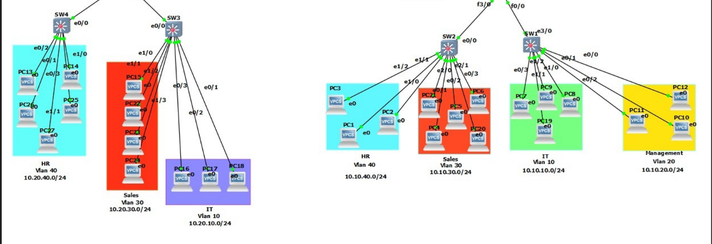
Figure 3: VLAN and Subnet Allocation Diagram
VLAN & Inter-VLAN Testing
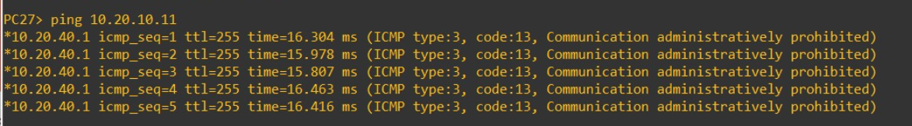
Figure 4: Ping Test from Branch HR VLAN (10.20.40.0/24) to Branch IT VLAN (10.20.10.0/24).

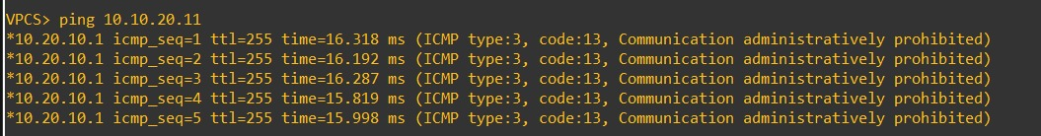
Figure 5: Ping Test from Branch IT VLAN (10.20.10.0/24) to HQ Management VLAN (10.10.10.0/24).

DHCP Configuration and Testing
Dynamic Host Configuration Protocol (DHCP) was implemented on both the HQ and Branch networks to automate IP address assignment for all VLANs. Each VLAN has its own DHCP scope, ensuring that every device receives the correct IP address, subnet mask, and default gateway according to its departmental network.
To validate the configuration, multiple client devices were set to obtain an IP address automatically. Each device successfully completed the DHCP DORA process (Discover, Offer, Request, Acknowledgment) and received an IP address from the correct VLAN pool.
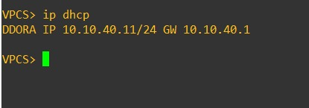
Figure 6: IP DHCP Testing

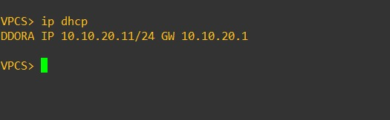
Figure 7: IP DHCP Testing

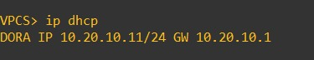
Figure 8: IP DHCP Testing
Routing Configuration
Static Routes:
HQ Static Routes:
Destination | Next Hop | Purpose
0.0.0.0/0 | via port1 (local entry) | Default gateway
10.20.0.0/16 | via HQ-to-Branch tunnel | Reach all Branch VLANs

HQ OSPF:
- Router-ID: 1.1.1.1
- Area: 0
- Interface: port1
- Networks advertised:
- 10.10.10.0/24
- 10.10.20.0/24
- 10.10.30.0/24
- 10.10.40.0/24
- Redistributes: static, connected, RIP, BGP, ISIS

Branch Static Routes:

Destination | Next Hop | Purpose
10.10.0.0/16 | via Branch-to-HQ tunnel | Reach all HQ VLANs

Branch OSPF:
- Router-ID: 2.2.2.2
- Area: 0
- Interface: port1
- Networks advertised:
- 10.20.10.0/24
- 10.20.30.0/24
- 10.20.40.0/24
- Redistributes: static, connected, RIP, BGP, ISIS

Routing Tables: Each router’s routing table was verified (show ip route) to confirm all VLAN subnets and remote networks are learned. OSPF neighbor relationships were confirmed (show IP OSPF neighbor), and routing metrics were inspected. The design follows best practices of unique OSPF router IDs and a single backbone area.

VPN SITE-TO-SITE
A secure IPsec VPN tunnel connects HQ and Branch FortiGate firewalls over the simulated Internet. Phase 1 (IKE): We configure IKEv2 with a peer identifier (the remote site’s public IP or DDNS name). Encryption is set to AES256, hashing to SHA256. A pre-shared key (PSK) is defined on both ends. Dead Peer Detection (DPD) is enabled for resiliency. The FortiGate automatically manage key exchanges.
Phase 2 (IPsec Selectors): We define the local and remote subnets to tunnel. The Phase 2 proposal also uses AES256/SHA256 (matching Phase 1’s algorithms) and configures Perfect Forward Secrecy. Traffic selectors include all corporate subnets between sites. On each FortiGate, firewall policies allow the permitted traffic to flow through the tunnel. The VPN parameters follow Fortinet’s recommended structure for site-to-site tunnels (explicitly matching proposals on both ends). Once up, the tunnel status is monitored (via FortiGate GUI or CLI).

Item | Value
Phase 1 Encryption | DES
Phase 1 Authentication | SHA256
Phase 1 DH Groups | 14, 5, 2
Phase 1 Key Lifetime | 86400 s
Phase 2 – vlan10 | 10.10.10.0/24 ↔ 10.20.10.0/24
Phase 2 – vlan30 | 10.10.30.0/24 ↔ 10.20.30.0/24
Phase 2 – vlan40 | 10.10.40.0/24 ↔ 10.20.40.0/24

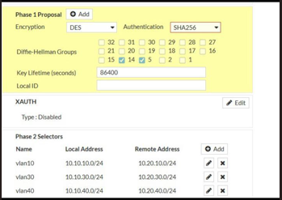
Figure 9: Site-to-site VPN Configuration

VPN Testing
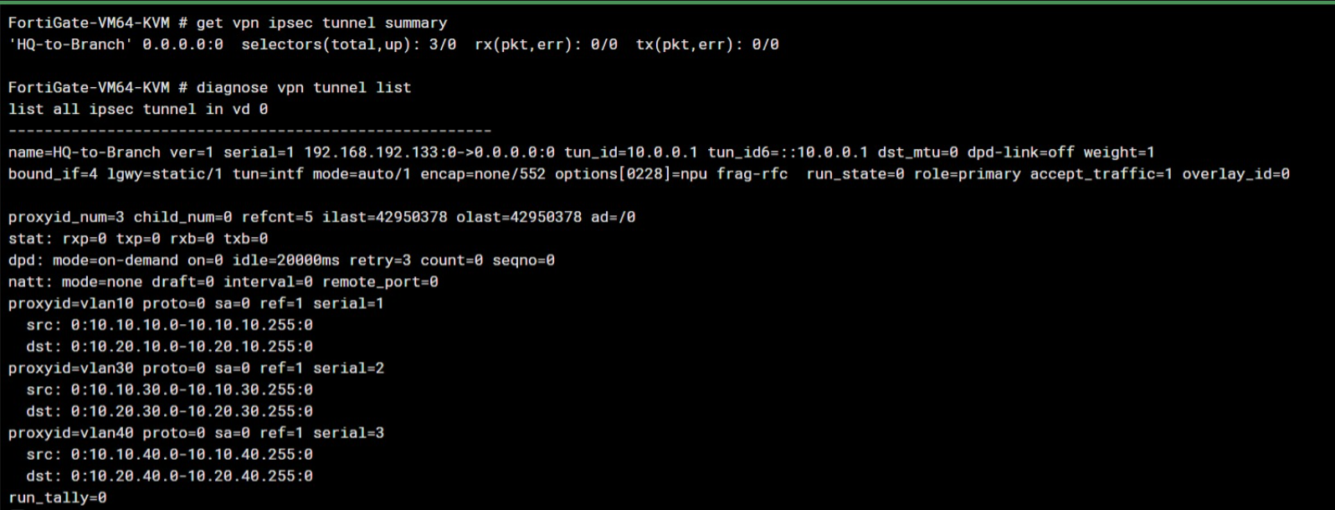
Figure 10: VPN testing

FortiGate and Security Services
The FortiGate firewalls provide layered security. Key services and configurations include:
- Firewall Rules: We created IPv4 policies to control inter-VLAN and Internet traffic. For example, LAN-to-WAN rules allow specific services (HTTP/HTTPS) out to the Internet and Block/deny all other unwanted traffic. Inter-VLAN routing policies ensure servers are reachable by clients. The implicit-deny in firewall policy logic is remembered (like an ACL) so only explicitly permitted flows pass.

- Web Filtering (FortiGuard): FortiGuard Web Filtering profiles are applied to outbound policies to block categories of malicious or undesired sites (e.g, malware, adult, social media as per policy). URL filtering is set to deny blacklisted domains. This enforces safe web access in compliance with corporate policy.

- Access Control Lists (ACLs): On the Cisco devices, IP access-lists restrict management access and demarcate zones. For instance, we limit SSH/HTTPS to network admins and block rogue protocol access. We note that in Cisco IOS, ACLs have an implicit “deny all” at the end, so each needed permit is explicitly entered.

- Port Security: On each switch, port security is enabled to lock MAC addresses on user access ports. This prevents unauthorized devices from connecting. We configure a maximum of 1 or 2 MAC addresses per port, with a restrict/violation action that shuts down the port if unknown devices appear.

- Local Authentication: The FortiGates use local user accounts for administrator login (password-based). Remote users also authenticate against FortiGate’s local user database. Two-factor OTP is enabled for admin login, enhancing security. User credentials are not passed clearly; FortiOS handles hashing and secure management access (SSH/HTTPS).

- DHCP Snooping: On the switches, DHCP snooping is enabled to prevent rogue DHCP servers. The switch builds a binding table of all legitimate DHCP leases from trusted ports. Only ports leading to the corporate DHCP server (FortiGate or Router) are marked “trusted”; all others are untrusted. This stops unauthorized DHCP servers from handing out incorrect IPs or gateways.

- High Availability (HA): Although single instances were used in GNS3, the FortiGates support active-passive HA clustering. In an HA scenario, the firewalls share a heartbeat link and synchronize configurations to provide failover. (In a production network, HA would ensure 24×7 firewall availability.)
Together, these services create a defense-in-depth posture. Traffic flows must satisfy multiple checks.
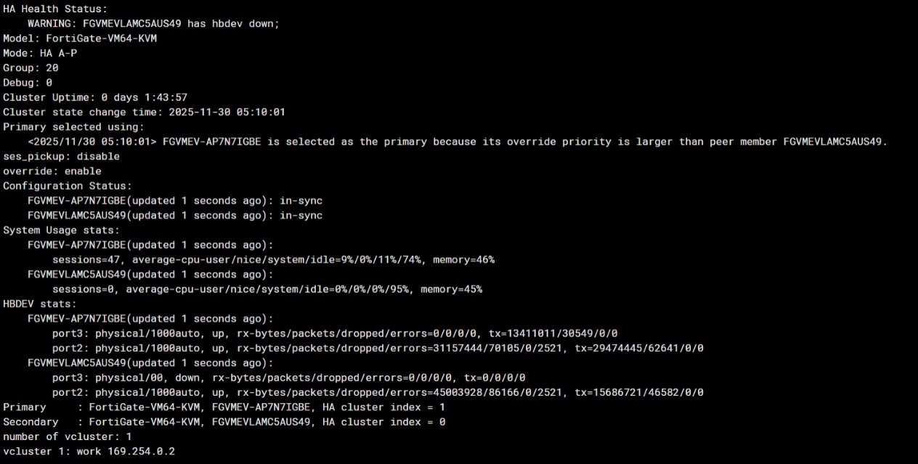
Figure 11: High Availability Testing

CCNA Topics Implemented
This network design covers essentially all CCNA-level topics:
- OSI/TCP Models & Addressing: We applied IPv4 and IPv6 addressing schemes.
- Routing: Both static and dynamic (OSPF) routing were implemented. OSPF adjacency ensure resilient path selection. The router IDs were chosen explicitly to be unique.

- VLAN Trunking & Inter-VLAN Routing: IEEE 802.1Q trunking is used to carry multiple VLANs on switch links. Inter-VLAN routing is handled by the router-on-a-stick or by the FortiGate. The design echoes Cisco’s model where a trunk link carries several VLANs and a router routes between them.

- Spanning Tree Protocol (STP): Switchports are configured for STP, preventing layer-2 loops in the topology. We ensured consistent spanning-tree priorities and that redundant links block appropriately.

- DHCP, DNS, NTP: Each site’s DHCP server (on the FortiGate) issues addresses to VLAN hosts. DNS requests from hosts are forwarded either to the Internet DNS or to a local resolver. NTP servers (both internal and external) keep device clocks synchronized.

- Access Lists & Port Security: Standard/extended ACLs filter traffic at routers and firewalls. Port security limits MACs on switch ports. These are textbook CCNA security measures.

- DHCP Snooping: As described above, we applied DHCP snooping on switches to protect the network – a common CCNA topic under “layer 2 security.”

Each of these topics was explicitly addressed and tested in the lab, reinforcing the theoretical CCNA concepts with practical configuration.

Conclusion
This project successfully demonstrates complete enterprise-style network implementation using GNS3. We achieved all goals: designing dual-site connectivity, segmenting networks via VLANs, securing traffic with FortiGate firewalls, and establishing a site-to-site VPN. Key CCNA skills were applied throughout, from IP planning and OSPF routing to ACLs and VLAN trunking. The resulting documentation and configurations are at professional standards, suitable for review by instructors or network engineers. In conclusion, the project confirms that complex, secure networks can be architected and validated virtually, and the network is ready for demonstration or further expansion (e.g, adding more branches, higher redundancy)

